EXPERIMENT NO. 7
Vulnerability Analysis using CGI Scanning with Nikto

Tool Used | Nikto v2.1.6

Platform | Kali Linux

Target Website | www.zoho.com / www.certifiedhacker.com
AIM
To perform web server vulnerability analysis and identify vulnerable CGI directories on a target website using the Nikto scanning tool.
TOOLS REQUIRED
- Kali Linux (with Nikto pre-installed)
- A target website/web server to scan
- Terminal access
THEORY
Nikto is an open-source web server scanner that performs comprehensive tests against web servers for multiple vulnerabilities, including outdated server software, dangerous files/CGI scripts, missing security headers, and misconfigurations. The -Tuning option lets a scan focus on specific vulnerability classes, while -Cgidirs instructs Nikto to specifically probe for and enumerate CGI directories that may expose exploitable scripts on the server.
PROCEDURE
Step 1: Open a terminal window and type nikto -H and press Enter to view the help menu.
Step 2: Type nikto -h <website> -Tuning x and press Enter to start a fully-tuned scan.
Step 3: Nikto starts web server scanning with all tuning options enabled.
Step 4: In the terminal window, type nikto -h <website> -Cgidirs all and press Enter.
Step 5: Nikto scans the webserver for vulnerable CGI directories and lists them out.
COMMAND FLAGS
Flag | Use | Example
-H | Display Nikto's help menu | nikto -H
-h <website> | Specify the target host/website to scan | nikto -h www.zoho.com
-Tuning x | Enable all tuning options for a thorough scan | nikto -h www.zoho.com -Tuning x
-Cgidirs all | Scan for vulnerable CGI directories on the webserver | nikto -h <site> -Cgidirs all
OUTPUT
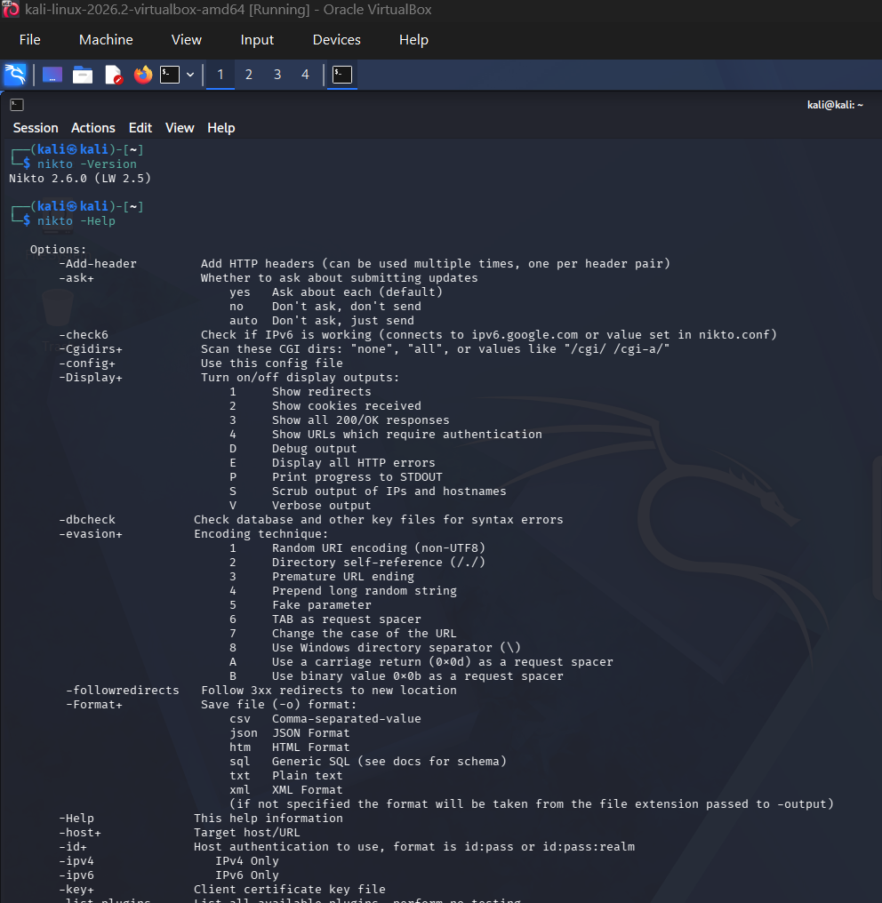

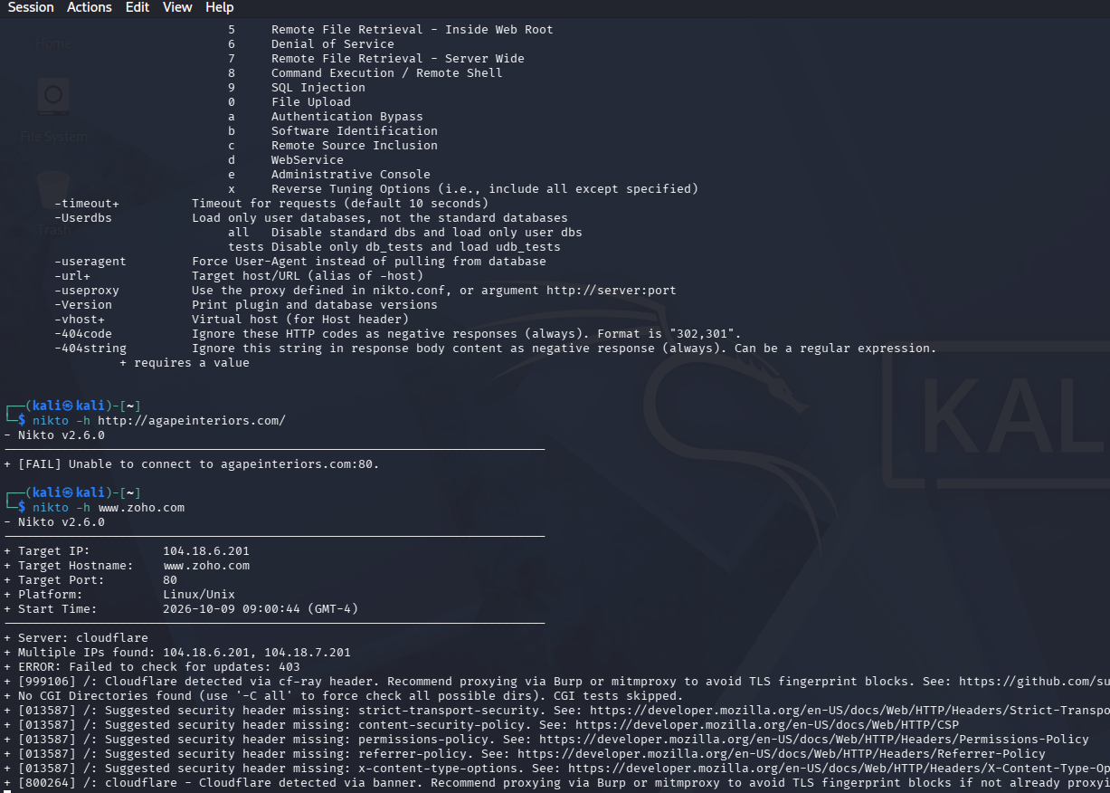
RESULT
Thus, vulnerability analysis of the target web servers was successfully performed using Nikto, and missing security headers along with CGI directory information were identified and recorded.

